Name: Bailey

Age: 18

Gender: Male

**Did you like the way the ship moves (the way it starts and stops moving), if not, why not?**

The ship movement felt that it was good enough to keep the ship in control.

**Did you like the speed of the rockets?**

The speed of the projectiles seem to work well with how fast the ship moved, however it was hard to distinguish the regular projectiles from the rockets.

**What are your opinion(s) on the way the rockets explode and affect the asteroids?**

I enjoyed the way that the two different rockets had differentiating effects because I could play defensively by pushing the asteroids away from myself as well as attacking the enemy player.

**Was the goal of the game readily evident when you started playing?**

No

**Do you like the art style? If not, what would you change?**

The art style seems to slightly change between the different objects, however, the background works well with how light the asteroids are which makes it easier to see them.

**Out of the options below, which UI do you prefer and why? What other information do you think should be included?**

I prefer the UI used on the left hand side of the first image as it clearly shows how much health the player has and what they can fire, it’s also better than the UI on the second image because it doesn’t hide a lot of the screen unlike the UI on the second image.

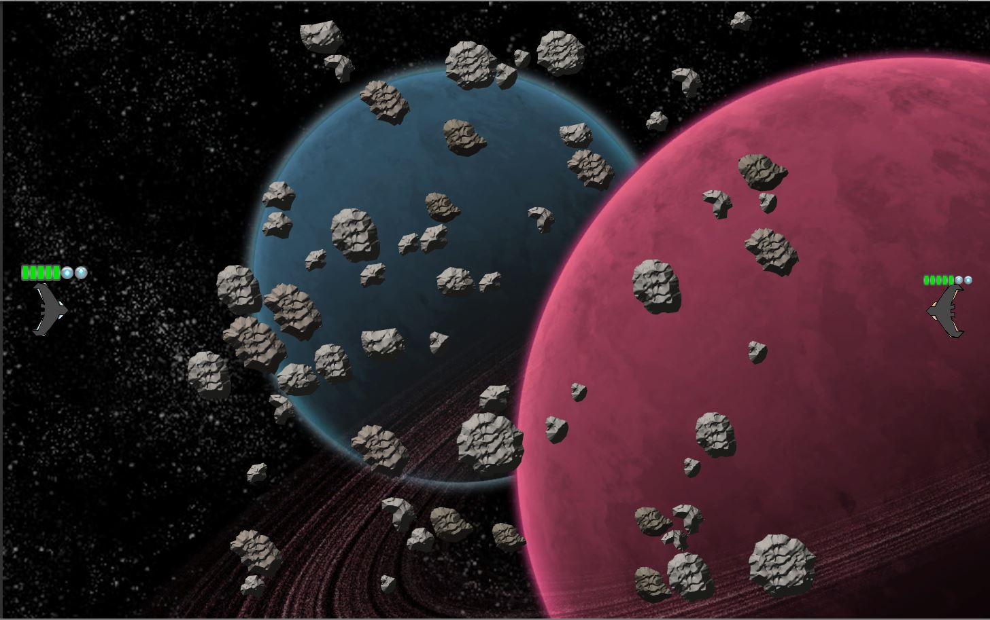

Figure : Same UI layout but different in size, is the right or left better?

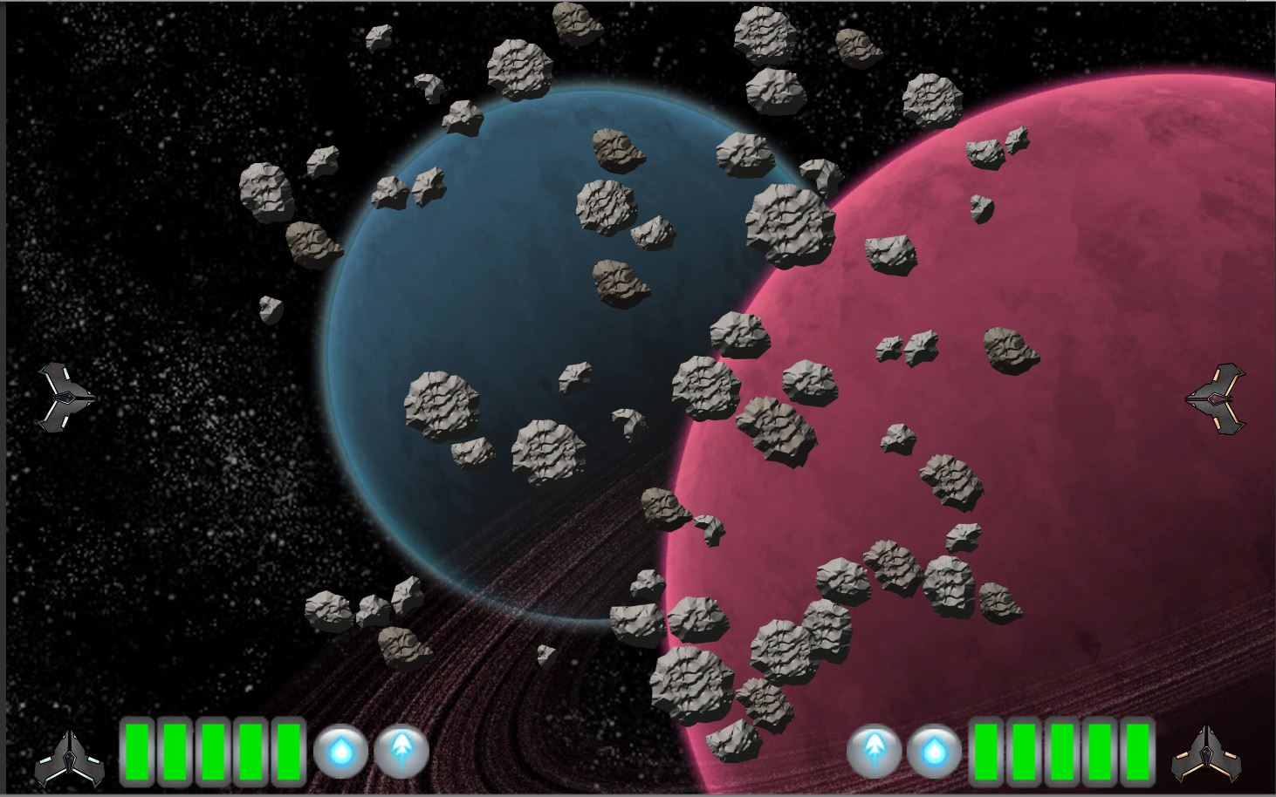

**If there is any missing information, what is it?**

There could be an on screen indicator as to which buttons are used for each players projectile

**Please give a short explanation of any bugs you have encountered**

The projectiles that were meant to look different looked the same.